**CHAPTER 1**

**INTRODUCTION**

* 1. **Background**

According to Merriam Webster, recommendation is the act of saying that someone or something is good and deserves to be chosen. We tend to give recommendation in our daily life such as recommending the best coffee in town to our best friends, giving a clue that the last Star Wars movie are worth watching. The essence of recommendation is reliable because we know that the item which is recommended by other people will more likely to satisfy us. As for in our Information Technology society, we define a system that give a recommendation to people is called a Recommender system (RS). This system has become more and more popular in our society and implemented in various application, because it could filter the related data that user interested rather than give all of information to the user. The most popular ones are probably to recommend movies, music, news, books, research articles, search queries, social tags, and products for people. In addition, in October 2006, a big company Netflix open a challenge for public in order to create a recommendation towards their movie recommendations. They offer 1 million US Dollar to improve their recommendation system called *Cinematch* by 10% improvements.

The reason we implement RS in our society are, to create a better content for the user. Firstly, by using RS, be could identify our user behavior. By monitoring their preferences and likes for a certain object the RS will create an output just as like a wizard who know what the customer wants. For example, the Last.fm create a station which contains recommended songs by calculating the user behavior towards the system. The system will also play the song which are not in the user library but played by other people who has similar taste to the music. This behavior also applies to the e-commerce recommendation system such as Amazon. By knowing the user preference, it will create an interactive perspective which give the user a good feeling seeing the item that RS has recommend and persuade them to buy or use the service.

Finally, conversion perspective which helps the company to grow. Such as, increase hit rate, optimize sales and profits margin, and many more. (Jannach, D). Recommendation also helps the company to plan what is the best item or move to be offered to the customer when selling their product or service. As for in IT terms, this tools can be seen in many applications for helping the customer making their next decision. For example, Amazon website, as the user can see several option after they bought or see several items in the website. It said the recommendation tool helps the market gain almost 35% of the profit rates. The other best example taken from “Now Touching The Void and Into Thin Air” example case. In 1988, a British mountain climber name Joe Simpson wrote a book which told his story to be the first to reach the summit of the Siula Grande in the Peruvian Andes with his friend. The book was having a good review which resulting a good success but soon disappearing in years later. Then a decade later, Jon Krakauer wrote a book Into Thin Air which also has the same plot with Joe Simpsons book. Instantly, Joe Simpsons book’s become hits again, the reason behind this is Amazon.com recommendation acknowledge the pattern of their customer buying behavior and told their user that if they liked Now Touching the Void then they will likely to like Into The Thin Air. Their user took the suggestion then it create an impact of a rising demand for unpopular book to become popular.

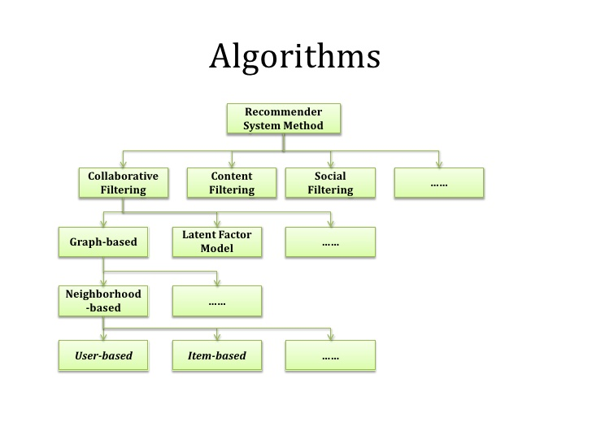

There are several other methodology regarding RS, but the most common algorithm was CBF. According to research conducted by Joeran Beel (2015), from 62 reviewed approaches, 34 used CBF (55%). From these CBF approaches, the majority utilized plain terms contained in the documents. However, there are some fascinating algorithm which can be used to the RS. The Natural Algorithm is an algorithm that mimic an animal or plant behavior to the system. Janusz Sobecki (2014) found that there are several natural algorithms that can be applied towards the RS. One of them is PSO (Particle Swarm Organization), this algorithm was invented in 1995 by Eberhart and Kennedy. This algorithm was based on several things which are, position, velocity and acceleration, and the movement of the particle around space. PSO can be referred as the school of fish, which each fish has their acceleration, coordinate, speed.

**1.2 Problem Definition**

Recommendation System has proven to bring great benefits towards human society. For example, it has become the tool for a company to attract more customer by giving them list of item that might interested. Not only it benefits the customer by giving them a less price or targeted item, but also benefits the company by giving them a loyal customer and profits. In these recent day, we can see many variables which can be put to the recommendation system which can be related to the RS. A context, which defined by Merriam Webster as the interrelated conditions in which something exists or occurs. A use of mobile device has a capability for monitoring user location and other service related that can play a part as the context for the RS. For instance, a location is a context which can be putted to a RS to create a recommendation to people near that location. In addition, time is another context that can be assign to give a specific time related recommendation to the user. The author believes, that by implementing the context to the RS will bring a great impact or improvement towards the accuracy to the RS.

**1.3 Aims and Benefits**

The Goal of this project can be defined in below

1. To implement context based for CF and CBF Algorithm
2. Creating an automation system or platform
3. Produce a recommendation dataset for PT. XYZ with the platform

The benefits of this thesis are

1. Help the current company to gain more customer and profits
2. The result of this thesis can become the foundation for other people when developing the next recommendation system
3. As the base foundation for the author to create a recommendation platform with the same or similar data in the future

**1.4 Scope**

The scope of this thesis are:

1. To identify which algorithm that produce the best result for the PT XYZ. The author will use Content Based Filtering and Collaborative Filtering as the basic recommendation algorithm to use in this thesis
2. The data sample will be collected from the PT XYZ and other source
3. Creating a platform of machine learning in order to process the data
4. The recommendation data will be shown in the company application which is in IOS Applications

**CHAPTER 2**

**THEORETICAL FOUNDATION**

In this chapter, the author will describe and explain regarding the theory that’ve been used for creating this thesis.

**2.1 Promotional Marketing**

According to McCarthy, Jerome E. (1964) Promotion can be define as to raising the customer awareness regarding services, item, improving sales, and getting customer loyalty to our product. There are several basic promotion type which available in our society. Firstly, there is a traditional promotion where the company gives the user a printable media such as column in a newspaper, electronic advertising such as in television and radio broadcast. Secondly, a new type of media which called digital promotion where the promotion can be spread using internets. Since almost 40% world population are online therefore the digital media prove to be the most effective way for company to expand their brand to their customer on their daily basis

**2.1.1 Promotional Model**

In the past 10 years, more than 200 studies regarding promotion has been published compare with year 1965 – 1983 which only 40 studies shown. Many definitions of promotions has been pass around the internet but it shares the common idea that promotions are a momentary and tangible modification of supply which has a purpose to create an impact towards customer, retailers, and sales behavior (Vemette 1990; Desmet 1991; Guilbert 1991; Ward and Hill 1991; Jones 1992).

In addition, according to .. the most widely accepted promotion topology contains three core foundations which are retail promotions, trade promotions, and consumer promotions. The topology is based on the nature of profits, effort, and relationship to the other product.

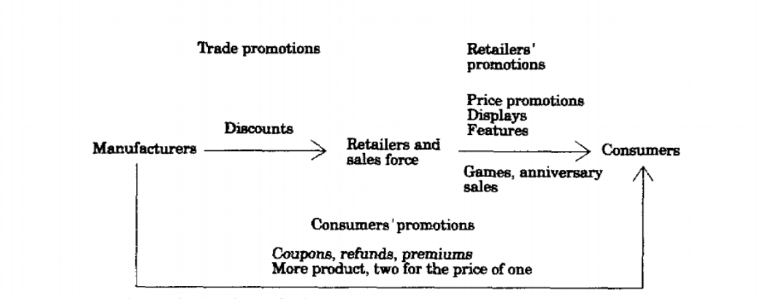

There are several contexts that need to be identify in the promotion model which shows in the figure below. First, the identification of frequent user on the based of risk theory

|  |  |
| --- | --- |
| **Dependent variable** | **Independent variable** |
| Intention to redeem the offered coupon | Self-declared familiarity |
| Redemption of direct-mail coupon | Brand purchases |
| Increase in the repurchase likelihood of new buyers |  |

Secondly we could identify the promotion based on economic theory. In this identification process we could define two type of variables which is mediating variable which based on cost and benefits analysis and independent variables which based on a household characteristics.

|  |  |
| --- | --- |
| **Mediating variable** | **Independent variable** |
| Substitution of a preferred brand for a less preferred, promoted brand | House of Ownership |
| Opportunity costs of time | Living in large cities |
| Inventory of stockpiled promoted brands. | Higher Education |
| Smart shopper feelings | Price Sensitivity |
|  | Size |
|  | Brand and store loyalty |
|  | Children |
|  | Working housewife |
|  | Income |
|  | Age |
|  | Sex |

**2.2 Recommendation System**

Now days, we can see a lot of recommender system (RS) in our modern society. Mostly, the system can be found in the application which has a huge amount of data collections. The reason behind the use of the RS is the system need to provide the user with a list of items that they might buy or interested. In addition, not only providing user with the list of items but also create a personalized RS for each different user.

The basic reason behind the implementation for recommendation system is revenue. Amazon, Netflix, Spotify, and Apple Music are some example of big company who implements RS on their business model. Which proven to increase user engagement towards their application. The company revenue will increase significantly with more user engagement to the application. One of the example for this statement is Netflix. We know that Netflix provide their user with a list amounts of films and the user need to pay a subscription monthly fee in order to get the services. As the user start to select, watch, and rate each of the movie, the RS create a unique list of movie for every user, which make the user want to try to see the recommended movie.

The other simple example is “Now Touching The Void and Into Thin Air” example case. As the author already mentions it in the Chapter 1. Amazon prove that RS could increase their revenue towards relating items in a big collection amount of data.

**2.3 Phases of recommendation process**

The figure below shows the process of RS in order to give a recommendation towards user.

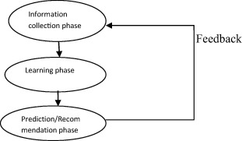

**2.3.1 Information collection phase**

In this context, the system needs to put the relevant information in order to create a user profile or a model for the process of recommendation. This information includes the user attributes and behavior of the accessed content. The system needs to need as many attributes of the user in order to create a reliable recommendation from the data. In this context, we can observe user through different ways. Firstly, to ask the user regarding their interest or preference for a specific item. The most common feedback we can see in our society is rating system. In addition, another input can be assessed by observing user behavior. Finally, hybrid feedback can also be collect by combining those two methods.

**2.3.1.1 Explicit feedback**

Like the author has briefly discuss below, the system or application will send a form of interface so the user can provide ratings to an item. This process will improve the accuracy for the user model in determining more reliable data. The recommendation system accuracy feedback will be fully determined by the quality of the feedback from the user. On one hand, using explicit feedback will bring a great impact towards the recommendation system because it gives a direct and more reliable data from the user. On the other hand, since the explicit feedback need more effort from the user, sometimes the user does not ready to put enough information to the system or application.



**2.3.1.2 Implicit feedback**

While the explicit feedback asks directly to the user for the feedback towards the item. The implicit feedback took feedback from monitoring the actions to the users. For example, the history of purchases, time spent looking in a specific web page, kind of category the user clicked the most. Which bring great benefits towards RS feedback system, because it subconsciously took the data from the user without the user put an extra effort to the system. Moreover, a research shows that the data from implicit feedback may be more objective because there’s no bias when the user do the actions.



**2.3.1.3 Hybrid feedback**

Both of pro and cons in doing the implicit and explicit feedback can be form into a hybrid system. The purpose of hybrid feedback is to minimize each of their weakness so the RS could perform the best feedback input from the user.

**2.3.2 Learning phase**

In this phase, the RS apply several algorithms to process the user feedback from the information collection process. The algorithm that common to be used are Collaborative Filtering (CF) and Content Based Filtering

**2.3.3 Prediction/recommendation phase**

After RS finish doing the learning phase, it will start to provide predictions towards what item that user is preferred. This data set can be made from several methodologies which from memory based or model based

**2.4 Recommendation Algorithm**

The first research recommender paper was introduced by Giles et al (1998). The paper was discussing about Bibliographic screening techniques as a part of CiteSeer project. As the time pass by, more than two hundred research article regarding RS has been published with different concepts and approach in order to create the best RS. According to by Joeran Beel (2015), half of the RS (55%) is using content based filtering as their approach, while the second most used algorithm is collaborative filtering (16%). While the other are spread for using graph database, stereotyping, and hybrid recommendations.

**2.4.1 Content Based Filtering**

Content Based Filtering (CBF) is one of the most widely use algorithm in RS implementation. A brief definition of CBF is to find a related dimension or domain towards an item so it can be referred to the user. The biggest benefits towards using CBF is it does not require as much user feedback to make the RS works. ( ) The CBF mostly use terms of Items, Interactions, and features in order to generate recommendation. For instance, “item” can be assume as a book and the “interaction” can be putted as buy, see, like, vote, downloading, etc. In addition, each items has in own features or tag that can be listed to.

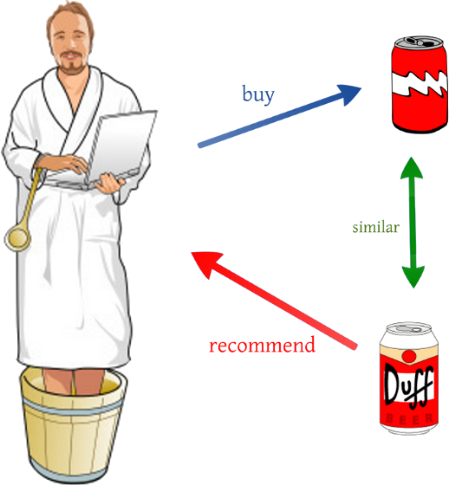

This are the simple example of CBF, as we can see if a person who likes beer with label A and if there exist another beer with label B who shares the same feature with the first beer. Therefore, the person who likes to buy beer A will most likely to buy beer B.

CBF proven to be a natural approach for RS in many problems. For instance, when a person watches a Starwars episode one and two. The most logical action is to recommend the third episode of the Starwars. However, the features of each items are hardly defined, the items context is dependable towards the descriptive of data. This problem will cause some user to get a similar recommendation which already showed to their profiles. In addition, Content-based filtering also ignores quality and popularity of items (R. Dong, L. Tokarchuk, and A. Ma, “Digging Friendship: Paper Recommendation in Social Network,” in Proceedings of Networking & Electronic Commerce Research Conference (NAEC 2009), 2009, pp. 21–28)

**2.4.2 Collaborative Filtering**

This approach is probably the second best approach for RS. The Collaborative Filtering (CF) is created by building a big dataset of user preferences for items then pair it to the other user with the same interest by calculating the similarities between them. The usual terms that CF tend to use is neighborhood.

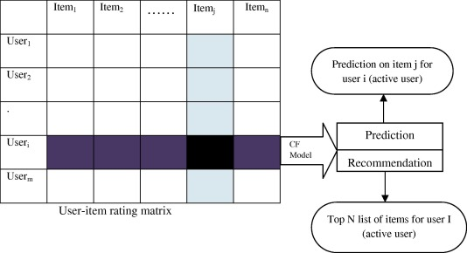

As we can see from the graph, CF use matrix to match targeted user from the other user perspective. By matching the matrix, the RS could create recommendation and prediction towards the user. () The major limitation for CF is the reliance towards user choices and the most common problem for using this algorithm is the cold start problem scenario. In this scenario, the items which presented to the user does not enough rating which will create a poor recommendation result to the user. By general CF can be categorize into two parts which are memory based and model based filtering.

**2.4.2.1 Memory based techniques**

The idea behind this technique is to find a relation between user and items from the database. The items that already rated by the user will search a neighbor that shared the same interest with the user. The neighbors usually have a history of doing or approving with the targeted user. For example, they both share the same interest for buying the particular item. The Memory based CF can be done by using two techniques which is user or item based technique.

The first technique (User Based) will calculate the similarity between user and compare their preference to the same item. After the data has been achieve, then the system will compute the prediction of rating.

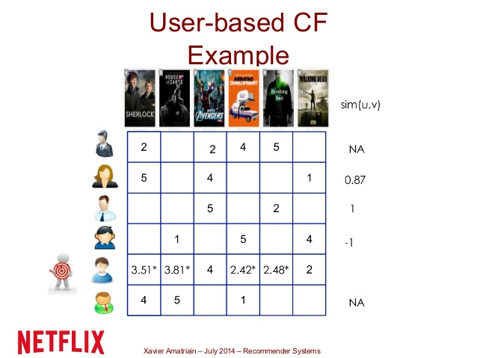

The illustration below shows; the user based CF was performing in the small data set of movie system. As we can see, the RS wants to predict the rate for each movie based on their neighbor who has the same interest to the same kind of movie.

The second technique for memory based recommendation is item based CF Recommendation. To find an item which the targeted user has liked before is the based foundation for this CF technique. The item based technique will retrieve all items that has been rated by targeted user. After the data has been collected then it will compare the number to the targeted items to determined the similarity between both items. Noted in this techniques takes only the known similar item ratings by the test user into account for prediction

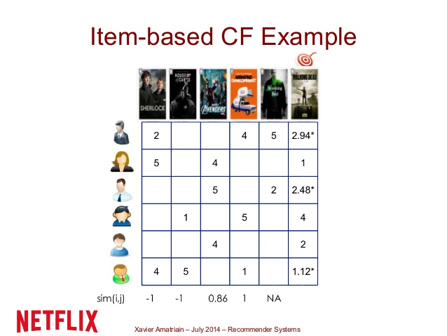

In order to measure the correlation between two most popular items, Pearson correlation is used and the algorithm can be defined as

iew the MathML source

From the figure below the s(a,u) explain the similiarity between two user a and u while ra,i is the input rating which set from the user a. In addition, ra‾‾ is the mean rating which has been set by the specific user while n is the number of items. Moreover, we could also calculate the deviation from neighbor mean by applying this formula,



**2.4.2.2 Model based techniques**

This technique will utilize the whole database to generate prediction and recommendation. Model based use the previous rating in order to create or examine a model. This model will be revised as the system or ratings grow which will give a high quality for the user. One of the model based technique used in the real world is Neflix Prize. In brief, Netflix create a competition to public in order to improve their recommendation system. After several years pass by, in the last year of competition year (2007), Netflix Prize end with two top models which is Singular Value Decomposition (SVD) and Restricted Boltzman Machine (RBM).

Both of the algorithm are only a part from many possible algorithms that can be apply for the model based technique recommendation. The use of each algorithm is depend on the style of the customer in selecting a product. In the section below, the author will describe some of common used models when selecting model based technique for recommendation.

**2.4.2.2.1 Association Rule**

This model was used when the data mining wants to predict the connection between items in a actions towards them. In real life, an example of study case might be like a number of customer who buy soap in a general store often buy a toothpaste at the same time. This model will calculate the connection between them and might find that 70% of the checkout section that contain soap also contain toothpaste as the same time. The effectiveness of association rule often used to analyze sales of transaction and the impact towards them is already known from a quite sometime.

**2.4.2.2.2 Clustering**

Clustering algorithm attempts to grouped a set of data into a set of smaller group in order to create more meaningful group inside that datasets. This algorithm often used in pattern recognition, statistical data analysis, and image processing. When a cluster has been created, the user feedback to each cluster can be calculated and process in order to create a more specific cluster which fit for the next predictive in RS. A good clustering algorithm will produce a cluster where the intra-cluster similarity is high and the inter-cluster similarity is low. In the RS approach, the user must play a part in clustering process and will be calculated by using degree of participation. The most common algorithm for this algorithm is using K-means which showed in figure below



Given a set of remarks (x1, x2, …, xn), where each inspection is a d-dimensional real vector, this algorithm of clustering aims to partition the n observations into k (≤ n) sets S = {S1, S2, …, Sk}

**2.4.2.2.3 Decision tree**

This methodology was based using tree graph which created by calculating a set of collection of data with their attributes. The decision tree is trained algorithm which mean if the training was correct then it will produce a very reliable data or prediction in RS. However, there are some advantage and disadvantages for using this algorithm which is, Firstly the algorithm is capable for generate an understandable rule for human to read. In addition, it could perform classification without to many hassle on doing computation towards the system. However, decision tree will perform poorly in small data set of case and not suitable for prediction in continuous attributes since it not capable for doing dynamic improvements (add new value).

**2.4.2.2.4 Artificial Neural network**

Artificial Neural Network (ANN) is using terms of neurons when applying their algorithm. The algorithm is to find how many connected neurons in the system in a logical way. The neurons can be interpreting as a computational unit which will receive inputs, process the data in order to give an output. The connection between neurons can be in unidirectional or bidirectional.



In the figure below shows how ANN is modeled. There are basically consist of some fundamental attributes such as inputs which contains of several weights inside of its and by using activation function which calculate or computed the data, and then gives an output. The benefits for using ANN model is to estimate nonlinear computation and collecting complicated connection in a collection of data. While the disadvantage for using this algorithm is to come up with the correct or fit network topology for the problem.

**2.4.2.2.5 Bayesian Classifiers**

Bayesian Classifiers are a probabilistic framework for solving a grouping problems which took the definition of conditional probability and using the Bayes Theorem. The basic Bayes Theorem for Bayesian Classifiers is



Whre p(Ck|x) is the probability of instance x in Ck and p(x|Ck) is the probability of generating instance x given class of Ck. Moreover, p(X) is the number of instance x occurring and p(Ck) is the number of instance Ck is occurring too. By using this theorem as foundation, we could apply naïve Bayesian classifiers which able to solve a record of N features (A1, A2, …, AN), the goal of the classifier is to predict class Ck by finding the value of Ck that maximizes the subsequent probability of the class given the data P(Ck|A1, A2, …, AN).

The main benefits of Naive Bayes classifiers are that they are robust to isolated noise points and irrelevant attributes, and they handle missing values by ignoring the instance during probability estimate calculations. In addition, they are fast to train and classify. However, the neutrality assumption may not grasp for some attributes as they might be associated. Which for RS the Bayesian are more suitable with a slow change of user preferences not a real time or rapid changes.

**2.4.2.2.6 Matrix completion techniques**

The purpose of this algorithm is to predict the unknown values in the user item matrices. One example of this problem could be seen in below where the RS wants to predict the score of one movie for specific user. In most of RS, they have a big key set value paired matrix data and the scrubby amount of data which due the reason that some users does not input the value most of items in the matrix system. This problematic issue sometimes cause the RS are unable to give a reliable and accurate output towards the user.

One of wide use algorithm for calculating Matrix completion technique is Alternating Least Square. This algorithm helps to minimize the square error over observed entries while keeping other factors fixed.. Keshavan et al. used SVD technique in an OptSpace algorithm to deal with matrix completion problem. The result of their experiment proves that SVD is able provide a trustworthy initial evaluation for bridging subspace which can be further refined by gradient descent on a Grassmannian manifold which later known as SGD.

Model based techniques solve sparsely problem. The major drawback of the techniques is that the model building process is computationally expensive and the capacity of memory usage is highly intensive. Also, they do not alleviate the cold-start problem.

**2.5 DBMS**

A database management system (DBSM) is a tools for computer system in order to create and maintain databases. This system provides a organized way for user and programmers in order to do a Create, Update, Read, and Delete data (CRUD). This tools have a core function for maintaining three important parts which are the data, data schema which define the database structure, and database engine which provide an access, security, and managing the data. This three core function help to provide concurrency, safety, data integrity, and uniform management procedure. In addition, DBSM also capable for doing role back (running a previous version of a database), restarts, and recovery function.

The DBMS is probably a very useful tools in order to providing a unified view of data that can be accessed by several user using different platforms and locations. A DBSM can constraint the limit regarding the data access for each user. In addition, the end user and programs are capable for understanding where the data is stored because the DBMS handle all the requests.

**2.5.1 Relational Database Management System**

There are several popular DBMS model such as Relational database management system (RDMS) which adaptable to most problem in software engineering. This database support the relational data model, which defined by the table name and a certain number of data with data types. The RDMS use record as a row in the table which contain several values for each attributes. The basic operation for this RDMS include classical set of operations such as union, intersection, and difference. In addition, the user also capable for doing a selection for a subset of record with several criteria such as contain. The RDMS also capable for doing projection which able to select a subset of attributes in the table. Finally the most useful operation in RDMS is join, which enable the user to combine multiple table. The example for RDMS is Oracle. However, although it could solve almost the problem, the RDMS can be quite expensive for development.

**2.5.2 Document Stores**

The next type of DBSM is NoSql DBSM which suited for loosely data structure that might grow in the future. NoSql also can be defined as Document Stores. This database model has several characteristic, firstly, the records does not have uniform structure (different records might have different columns). Secondly, the types of values in each column can be differ from one another. In addition, each column may have more than one value. Finally, record can have a nested structure (append values). In the real practice, the Document stores often use internal notations such as JSON. Wide column stores is another example of DBSM which could handle a very large numbers of dynamics columns. This type of DBSM can be seen as two dimensional key stores values. Since the column and record key are not fixed. This type of DBSM share the same attributes with the NoSQL DBMS but the implementation in the real practice is quite different.

**2.5.3 Graph Database**

According to data from DB-Engines a website that tracks database popularity, Graph databases were the fastest growing type of database in 2014. This database represent data in a graph projection using terms nodes and edges. By doing this, graph database allows easy processing and simple calculation of the data. An example for graph database is neo4j graph database.

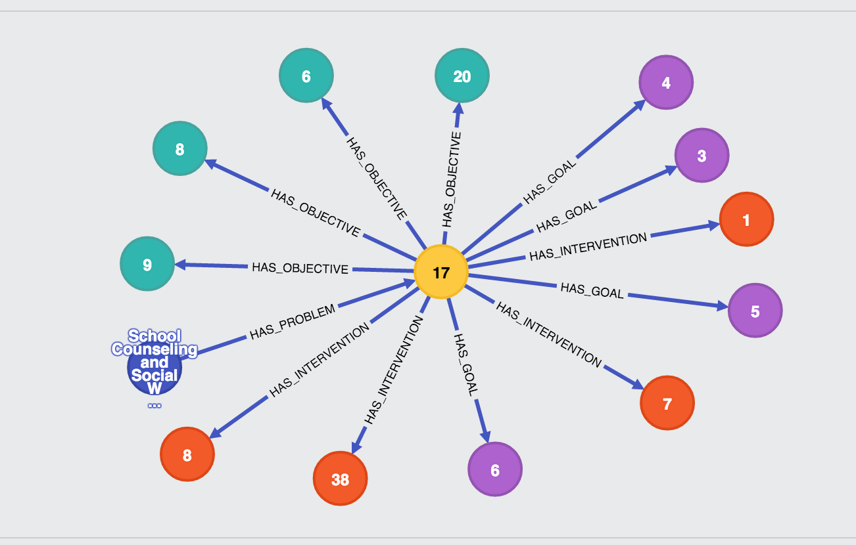

In the figure below shows the representation neo4j for data (node) with their edge. As we can see each of node has different color representing its model and the arrow represent the edge as the function for each node. The pro’s for using graph database according to Josep Lluis Larriba Pey are the graph database allow programmer to deep transversal quicker than traditional database. Moreover, the graph database tend to query faster when finding a connection between nodes which shares the same preferences in their edge. The cons for graph database is the maturity for its system because it is a growing technology.

**2.6 Big Data Processing**

The main function or purpose for using big data processing is to help a user to create more informative business decision by doing research and development in a big amounts of data transaction. This process could use a logs of a web server, social media content, social network action reports, emails, call details, and many more. This big data can be analyzed thanks to the software tools that capable doing predictive analytics, data mining, statistical and text analytics. There are several cases that need to be calculated when doing a big data processing. Firstly, some of data warehouses might not be able to process a big set of data that need to be shown instantly (real time data). This example can be seen in a applications of oil and stock exchanges. To handle this problem, a newer technology must be applied to the company system such as using Hadoop and related tools such as YARN, Elastic Search, Spark, and many more.